public class MyClass {

static int sum=0;

public static void main(String [] s) {

for(int i=0;i<s.length;i++){

sum=sum+Integer.parseInt(s[i]);

}

System.out.println("sum is "+sum);

}

}

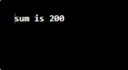

public class MyClass {

public static void main(String [] s) {

for(int i=0;i<s.length;i++)

System.out.println(s[i]);

}

}

